SOFTWARE MANAGEMENT SYSTEM
A DBMS Capstone Project Report submitted in partial fulfillment of the requirements for the award of the degree of

BACHELOR OF TECHNOLOGY
in

ARTIFICIAL INTELLIGENCE AND MACHINE LEARNING

Submitted By
B.Reshma-26B21AI012
A.Chandini-26B21AI002
T.Harika-25B11AI982
T.Bhargavi-25B11AIC15
- Under the esteemed guidance of
Mrs. G L Narasamba Vanguri, M.Tech, (Ph.D.)

Assistant Professor


DEPARTMENT OF ARTIFICIAL INTELLIGENCE AND MACHINE LEARNING

ADITYA UNIVERSITY
(Formerly Aditya Engineering College (A))
Aditya Nagar, ADB Road, Surampalem, Andhra Pradesh, India

2026 – 2027


Aditya Nagar, ADB Road, Surampalem, Andhra Pradesh, India
DEPARTMENT OF ARTIFICIAL INTELLIGENCE AND MACHINE LEARNING

CERTIFICATE

This is to certify that the DBMS Capstone Project report entitled "Software Management System" is being submitted by B.RESHMA (Roll No. 26B21AI012), A.CHANDINI (Roll No. 26B21AI002), T.HARIKA (Roll No. 25B11AI982) and T.BHARGAVI (Roll No. 25B11AIC15) in
partial fulfillment of the requirements for the award of the B.Tech. degree in Artificial Intelligence and Machine Learning. The work documented in this report was carried out as part of the Capstone Project for the course Database Management Systems (2501IT05) during the academic year 2026-2027, and records the database design, implementation, and documentation undertaken by the team for a software project management domain.

Project Guide Head of the Department
Mrs. G L Narasamba Vanguri, M.Tech, (Ph.D.) Dr. K. Naga Bhargavi, M. Tech, Ph.D.
Associate professor Associate Professor & HOD

External Examiner

DECLARATION

We hereby declare that the DBMS Capstone Project entitled "Software Management System" is a genuine work carried out by us. The database design, SQL implementation, queries and documentation presented in this report are our own work, completed under the guidance of Mrs. G L Narasamba Vanguri, M.Tech, (Ph.D.), Department of Artificial Intelligence and Machine Learning, Aditya University, Surampalem. We further declare that this work has not been submitted, in full or in part, for the award of any degree of this or any other educational institution.

Project Associates

B.RESHMA(26B21AI012)
A.CHANDINI(26B21AI002)
T.HARIKA(25B11AI982)
T.BHARGAVI(25B11AIC15)

Date: 14 September 2026
Place: Surampalem

ACKNOWLEDGEMENT

It is with immense pleasure that we express our indebted gratitude to our project guide Mrs. G L Narasamba Vanguri, M.Tech, (Ph.D.), Department of Artificial Intelligence and Machine Learning, who guided us throughout the capstone project. We are thankful for the constant encouragement and valuable suggestions received at every review stage.
We are grateful to Dr. K. Naga Bhargavi, Head of the Department, for inspiring us and for arranging the facilities and resources needed for this project.
We extend our sincere thanks to the Management, Dr. M. Sreenivasa Reddy, Deputy Pro-Chancellor, Dr. M. B. Srinivas, Vice-Chancellor, and Dr. A. Ramesh, Pro Vice-Chancellor (Engineering & Sciences), for providing an excellent academic environment.
Not to forget, we thank the Teaching and Non-Teaching Staff, our parents and our friends, who have directly or indirectly supported us in completing this project on time.

Project Associates
BB.RESHMA(26B21AI012)
A.CHANDINI(26B21AI002)
T.HARIKA(25B11AI982)
T.BHARGAVI(26B21AIC15)

ADITYA UNIVERSITY
Surampalem
Department of Computer Science and Engineering

DBMS CAPSTONE PROJECT


Project Documentation Report
Project Title: Bank Account Management System
Submitted by:
Course: Database Management System (DBMS) Course Code: DBMS
Faculty Coordinator:
Academic Year: 2026–27
Date of Submission: September 2026
GitHub Repository Link:

S.No | Student Name | Roll Number
1 | B.RESHMA | 26B21AI012
2 | A.CHANDINI | 26B21AI002
3 | T.HARIKA | 25B11AI982
4 | T.BHARGAVI | 25B11AIC15

ABSTRACT

The Software Management System is a relational database project designed to manage software projects, clients, employees, modules, tasks, and issue tracking in one organized system.
The system consists of six main entities: Client, Employee, Project, Module, Task, and Issue, connected through foreign-key relationships to maintain data consistency across project planning, assignment, monitoring, and support activities.
integrity.
Built using SQL and normalized up to Third Normal Form (3NF), the system uses NOT NULL, UNIQUE, and CHECK constraints to maintain accurate and valid data.
The system supports customer management, savings/current/fixed-deposit accounts, deposits, withdrawals, transaction recording, and loan tracking. SQL queries demonstrate joins, aggregate functions, GROUP BY/HAVING, subqueries, and reporting operations.

TABLE OF CONTENTS

Chapter | Title | Page No.
 | Certificate | i
 | Declaration | ii
 | Acknowledgement | iii
 | Project Documentation Report | iv
1 | ABSTRACT | v
 | List of Figures | vii
 | List of Tables | vii
2 | INTRODUCTION | 1
 | 2.1 Background | 1
 | 2.2 Purpose of the Database | 1
3 | PROBLEM STATEMENT | 1
4 | OBJECTIVES | 1
5 | TOOLS & TECHNOLOGIES USED | 2
6 | DATABASE DESIGN | 2
 | 6.1 Identified Entities | 2
 | 6.2 Entity Attributes | 2
 | 6.3 ER Diagram | 4
 | 6.4 Relationships & Cardinality | 4
 | 6.5 Relational Database Schema | 4
 | 6.6 Normalization | 6
7 | DATABASE IMPLEMENTATION | 8
 | 7.1 DDL — Database and Table Creation | 8
 | 7.2 Sample Data — DML. | 10
 | 7.3 Constraints & Data Integrity | 10
 | 7.4 SQL Operations & Queries | 10
 | 7.5 Sample Outputs / Screenshots | 12
8 | MODULES & FUNCTIONALITIES | 14
9 | GITHUB REPOSITORY & TEAM RESPONSIBILITIES | 14
10 | ENHANCEMENTS & FUTURE IMPROVEMENTS | 15
11 | CONCLUSION | 15
12 | REFERENCES | 15
 | APPENDIX | 16
 | A. Complete SQL Script | 16
 | B. Additional Screenshots / Outputs | 16

LIST OF FIGURES
LIST OF TABLES

Figure No. | Title of the Figure | Page No.
6.3 | ER Diagram | 4
Figure 1 | Employee records / basic SELECT output | 12
Figure 2 | In-progress projects / filtering output | 12
Figure 3 | Aggregate or GROUP BY output | 13
Figure 4 | Join or subquery output | 13

Table No. | Title of the Table | Page No.
5 | TOOLS & TECHNOLOGIES USED | 2
6.1 | Identified Entities | 2
6.2 | Entity Attributes | 2
6.4 | Relationships & Cardinality | 4
6.5 | Relational Database Schema | 4
7.2 | Sample Data — DML. | 10
7.3 | Constraints & Data Integrity | 10
7.4 | SQL Operations & Queries | 10
8 | MODULES & FUNCTIONALITIES | 14
9 | GITHUB REPOSITORY & TEAM RESPONSIBILITIES | 14

INTRODUCTION

Background
Software organizations handle structured information related to clients, employees, projects, modules, development tasks, deadlines, issue reports, and delivery status. A relational database is required to store this information consistently and to maintain relationships between the different records. In this project, the software management domain is represented using six related tables: Client, Employee, Project, Module, Task, and Issue. The schema separates data into appropriate entities and uses keys and constraints to reduce duplication and protect data integrity. SQL queries are then used to retrieve, update, aggregate, and analyse the stored information.

Purpose of the Database
The database provides a centralized structure for managing client details, employee profiles, project schedules, module ownership, assigned tasks, and reported software issues. It can support project managers, team leads, developers, testers, and administrators who need to retrieve project/task information, track employee workload, monitor delivery progress, record issue resolution, and generate summary information. The relationships between the tables allow related information to be accessed through SQL joins and subqueries instead of maintaining disconnected records.

PROBLEM STATEMENT
Manual or spreadsheet-based project tracking can lead to duplicate client records, unclear task ownership, inconsistent project status, and difficulty in monitoring software defects.
The proposed system centralizes client, employee, project, module, task, and issue information into a single relational database.
The system provides structured data management, referential integrity, validation and SQL-based reporting for efficient software project planning and monitoring.

OBJECTIVES
- Objective 1: Design a relational schema containing six related software management entities.
- Objective 2: Implement primary keys, foreign keys, NOT NULL, UNIQUE, CHECK, and DEFAULT constraints for data integrity.
- Objective 3: Populate the database with representative client, employee, project, module, task, and issue records.
- Objective 4: Demonstrate SQL retrieval, updates, joins, aggregate functions, GROUP BY/HAVING, and subqueries.
- Objective 5: Document the database design, implementation, sample data, queries, and team responsibilities.

TOOLS & TECHNOLOGIES USED

Category | Tool / Technology Used
Database Server | SQL-compatible relational database
Query / Admin Tool | SQL client / SQL environment
Front-end (if any) | Not specified in the uploaded SQL files
Operating System | Not specified in the uploaded files
Version Control | GitHub


DATABASE DESIGN

Identified Entities

S.No | Entity Name | Description
1 | Client | Stores client organization details, contact person, email, phone, city, and creation date.
2 | Employee | Stores employee identity, role, department, contact details, hire date, and working status.
3 | Project | Stores software project details, client ownership, manager assignment, schedule, budget, and status.
4 | Module | Stores project modules, lead employee, priority, due date, and development status.
5 | Task | Stores task assignments, task titles, estimated/actual hours, due dates, and progress status.
6 | Issue | Stores software issue reports, severity, status, reporting employee, dates, and resolution notes.

Entity Attributes

Entity | Attribute | Data Type | Key (PK/FK/-) | Attribute Type
Client | ClientID | INTEGER | PK | Simple
Client | Client Name | VARCHAR (80) | - | Simple
Client | Contact Person | VARCHAR (60) | - | Simple
Client | Email | VARCHAR (100) | - | Simple
Client | Phone | VARCHAR (15) | - | Simple
Client | City | VARCHAR (50) | - | Simple
Client | Created At | DATE | - | Derived/Default
Employee | Employee ID | INTEGER | PK | Simple
Employee | First Name | VARCHAR (30) | - | Simple
Employee | Last Name | VARCHAR (30) | - | Simple
Employee | Role | VARCHAR (40) | - | Simple
Employee | Department | VARCHAR (50) | - | Simple
Employee | Email | VARCHAR (100) | - | Simple
Employee | Phone | VARCHAR (15) | - | Simple

Entity | Attribute | Data Type | Key (PK/FK/-) | Attribute Type
Employee | Hire Date | DATE | - | Simple
Employee | Status | VARCHAR (15) | - | Derived/Default
Project | Project ID | INTEGER | PK | Simple
Project | Client ID | INTEGER | FK | Simple
Project | Project Name | VARCHAR (100) | - | Simple
Project | Start Date | DATE | - | Simple
Project | End Date | DATE | - | Simple
Project | Budget | DECIMAL (12,2) | - | Simple
Project | Status | VARCHAR (20) | - | Derived/Default
Project | Manager ID | INTEGER | FK | Simple
Module | Module ID | INTEGER | PK | Simple
Module | Project ID | INTEGER | FK | Simple
Module | Module Name | VARCHAR (80) | - | Simple
Module | Lead Employee ID | INTEGER | FK | Simple
Module | Priority | VARCHAR (15) | - | Simple
Module | Status | VARCHAR (20) | - | Derived/Default
Module | Due Date | DATE | - | Simple
Task | Task ID | INTEGER | PK | Simple
Task | Module ID | INTEGER | FK | Simple
Task | Assigned To | INTEGER | FK | Simple
Task | Task Title | VARCHAR (120) | - | Simple
Task | Task Status | VARCHAR (20) | - | Simple
Task | Estimated Hours | DECIMAL (6,2) | - | Simple
Task | Actual Hours | DECIMAL (6,2) | - | Derived/Default
Issue | Issue ID | INTEGER | PK | Simple
Issue | Project ID | INTEGER | FK | Simple
Issue | Module ID | INTEGER | FK | Simple
Issue | Reported By | INTEGER | FK | Simple
Issue | Issue Title | VARCHAR (120) | - | Simple
Issue | Severity | VARCHAR (20) | - | Simple
Issue | Issue Status | VARCHAR (20) | - | Derived/Default
Issue | Reported Date | DATE | - | Derived/Default
Issue | Resolved Date | DATE | - | Simple
Issue | Resolution Notes | VARCHAR (255) | - | Simple

ER Diagram

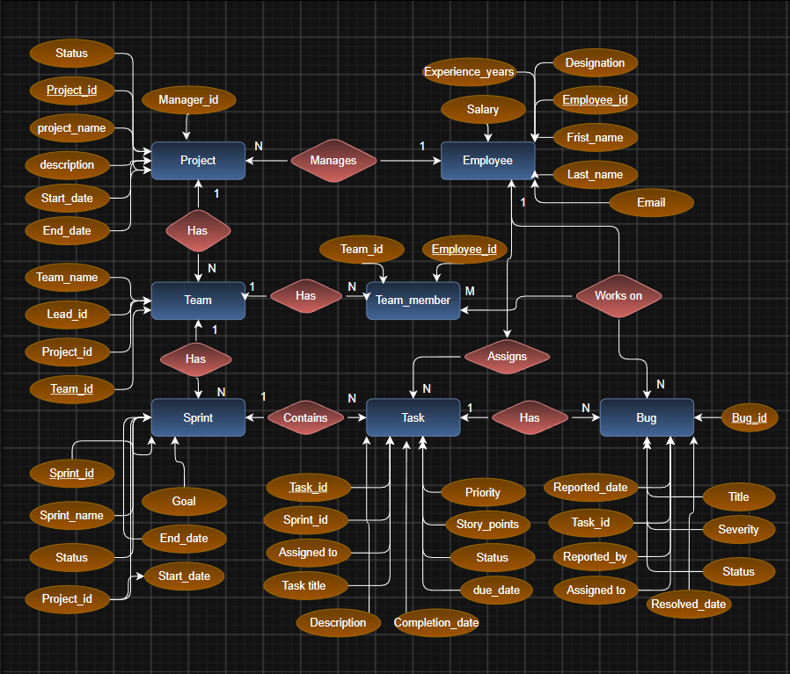

Relationships & Cardinality

Entity 1 | Relationship | Entity 2 | Cardinality (1:1 / 1:N / M:N)
Client | requests | Project | 1:N
Employee | manages | Project | 1:N
Project | contains | Module | 1:N
Module | contains | Task | 1:N
Employee | is assigned | Task | 1:N
Project | has | Issue | 1:N


Relational Database Schema

Table Name | Column Name | Data Type | PK/FK/- | Constraints
Client | ClientID | INTEGER | PK | PRIMARY KEY
Client | ClientName | VARCHAR(80) | - | NOT NULL
Client | ContactPerson | VARCHAR(60) | - | NOT NULL
Client | Email | VARCHAR(100) | - | NOT NULL, UNIQUE
Client | Phone | VARCHAR(15) | - | NOT NULL, CHECK length >= 10
Client | City | VARCHAR(50) | - | NULL allowed
Client | CreatedAt | DATE | - | DEFAULT CURRENT_DATE
Employee | EmployeeID | INTEGER | PK | PRIMARY KEY
Employee | FirstName | VARCHAR(30) | - | NOT NULL
Employee | LastName | VARCHAR(30) | - | NOT NULL
Employee | Role | VARCHAR(40) | - | NOT NULL
Employee | Department | VARCHAR(50) | - | NOT NULL
Employee | Email | VARCHAR(100) | - | NOT NULL, UNIQUE
Employee | Phone | VARCHAR(15) | - | NOT NULL
Employee | HireDate | DATE | - | NOT NULL
Employee | Status | VARCHAR(15) | - | DEFAULT Active, CHECK allowed statuses
Project | ProjectID | INTEGER | PK | PRIMARY KEY
Project | ClientID | INTEGER | FK | NOT NULL, FOREIGN KEY -> Client
Project | ProjectName | VARCHAR(100) | - | NOT NULL
Project | StartDate | DATE | - | NOT NULL
Project | EndDate | DATE | - | NULL allowed
Project | Budget | DECIMAL(12,2) | - | CHECK >= 0
Project | Status | VARCHAR(20) | - | DEFAULT Planned, CHECK allowed statuses
Project | ManagerID | INTEGER | FK | NOT NULL, FOREIGN KEY -> Employee
Module | ModuleID | INTEGER | PK | PRIMARY KEY
Module | ProjectID | INTEGER | FK | NOT NULL, FOREIGN KEY -> Project

Table Name | Column Name | Data Type | PK/FK/- | Constraints
Module | ModuleName | VARCHAR(80) | - | NOT NULL
Module | LeadEmployeeID | INTEGER | FK | NOT NULL, FOREIGN KEY -> Employee
Module | Priority | VARCHAR(15) | - | CHECK Low/Medium/High/Critical
Module | Status | VARCHAR(20) | - | DEFAULT Not Started, CHECK allowed statuses
Module | DueDate | DATE | - | NULL allowed
Task | TaskID | INTEGER | PK | PRIMARY KEY
Task | ModuleID | INTEGER | FK | NOT NULL, FOREIGN KEY -> Module
Task | AssignedTo | INTEGER | FK | NOT NULL, FOREIGN KEY -> Employee
Task | TaskTitle | VARCHAR(120) | - | NOT NULL
Task | TaskStatus | VARCHAR(20) | - | CHECK Open/In Progress/Review/Done
Task | EstimatedHours | DECIMAL(6,2) | - | NOT NULL, CHECK > 0
Task | ActualHours | DECIMAL(6,2) | - | DEFAULT 0, CHECK >= 0
Task | DueDate | DATE | - | NULL allowed
Issue | IssueID | INTEGER | PK | PRIMARY KEY
Issue | ProjectID | INTEGER | FK | NOT NULL, FOREIGN KEY -> Project
Issue | ModuleID | INTEGER | FK | FOREIGN KEY -> Module
Issue | ReportedBy | INTEGER | FK | NOT NULL, FOREIGN KEY -> Employee
Issue | IssueTitle | VARCHAR(120) | - | NOT NULL
Issue | Severity | VARCHAR(20) | - | CHECK Low/Medium/High/Critical
Issue | IssueStatus | VARCHAR(20) | - | DEFAULT Open, CHECK allowed statuses
Issue | ReportedDate | DATE | - | DEFAULT CURRENT_DATE
Issue | ResolvedDate | DATE | - | NULL allowed
Issue | ResolutionNotes | VARCHAR(255) | - | NULL allowed

Normalization
UNF -> 1NF -> 2NF -> 3NF
UNF: Software management information could be represented as a large combined record containing client, employee, project, module, task, and issue details.
1NF: The design separates repeating groups and keeps attributes atomic. For example, employee names and client contact information are stored in separate fields, while tasks and issues are recorded as individual rows.
2NF: Each entity is separated into its own table with a primary key so non-key attributes depend on the complete key.
3NF: Relationships are represented using foreign keys, so client, employee, project, module, task, and issue facts are stored in their appropriate tables rather than being repeatedly duplicated. This reduces update, insertion, and deletion anomalies.

DATABASE IMPLEMENTATION

DDL — Database and Table Creation
-- Drop tables if they exist
DROP TABLE IF EXISTS Issue; DROP TABLE IF EXISTS Task;
DROP TABLE IF EXISTS Module; DROP TABLE IF EXISTS Project; DROP TABLE IF EXISTS Employee; DROP TABLE IF EXISTS Client;

-- 1. CLIENT TABLE
CREATE TABLE Client (
ClientID INTEGER PRIMARY KEY, ClientName VARCHAR(80) NOT NULL, ContactPerson VARCHAR(60) NOT NULL, Email VARCHAR(100) NOT NULL UNIQUE,
Phone VARCHAR(15) NOT NULL, City VARCHAR(50), CreatedAt DATE DEFAULT CURRENT_DATE,
CONSTRAINT chk_client_phone CHECK (LENGTH(Phone) >= 10)
);

-- 2. EMPLOYEE TABLE CREATE TABLE Employee (
EmployeeID INTEGER PRIMARY KEY, FirstName VARCHAR(30) NOT NULL,
LastName VARCHAR(30) NOT NULL, Role VARCHAR(40) NOT NULL, Department VARCHAR(50) NOT NULL,
Email VARCHAR(100) NOT NULL UNIQUE, Phone VARCHAR(15) NOT NULL,
HireDate DATE NOT NULL, Status VARCHAR(15) DEFAULT 'Active' CHECK (Status IN ('Active','Inactive','On Leave'))
);

-- 3. PROJECT TABLE
CREATE TABLE Project (
ProjectID INTEGER PRIMARY KEY, ClientID INTEGER NOT NULL, ProjectName VARCHAR(100) NOT NULL,
StartDate DATE NOT NULL, EndDate DATE, Budget DECIMAL(12,2) CHECK (Budget >= 0),
Status VARCHAR(20) NOT NULL DEFAULT 'Planned' CHECK (Status IN ('Planned','In Progress','On Hold','Completed','Cancelled')),
ManagerID INTEGER NOT NULL,
FOREIGN KEY (ClientID) REFERENCES Client(ClientID),
FOREIGN KEY (ManagerID) REFERENCES Employee(EmployeeID)
);

-- 4. MODULE TABLE

CREATE TABLE Module (
ModuleID INTEGER PRIMARY KEY, ProjectID INTEGER NOT NULL, ModuleName VARCHAR(80) NOT NULL,
LeadEmployeeID INTEGER NOT NULL,
Priority VARCHAR(15) NOT NULL CHECK (Priority IN ('Low','Medium','High','Critical')),
Status VARCHAR(20) NOT NULL DEFAULT 'Not Started' CHECK (Status IN ('Not Started','In Progress','Testing','Completed')), DueDate DATE,
FOREIGN KEY (ProjectID) REFERENCES Project(ProjectID),
FOREIGN KEY (LeadEmployeeID) REFERENCES Employee(EmployeeID)
);

-- 5. TASK TABLE
CREATE TABLE Task ( TaskID INTEGER PRIMARY KEY, ModuleID INTEGER NOT NULL, AssignedTo INTEGER NOT NULL,
TaskTitle VARCHAR(120) NOT NULL, TaskStatus VARCHAR(20) NOT NULL CHECK (TaskStatus IN ('Open','In Progress','Review','Done')),
EstimatedHours DECIMAL(6,2) NOT NULL CHECK (EstimatedHours > 0),
ActualHours DECIMAL(6,2) DEFAULT 0 CHECK (ActualHours >= 0),
DueDate DATE,
FOREIGN KEY (ModuleID) REFERENCES Module(ModuleID), FOREIGN KEY (AssignedTo) REFERENCES Employee(EmployeeID)
);

-- 6. ISSUE TABLE CREATE TABLE Issue (
IssueID INTEGER PRIMARY KEY, ProjectID INTEGER NOT NULL, ModuleID INTEGER, ReportedBy INTEGER NOT NULL,
IssueTitle VARCHAR(120) NOT NULL, Severity VARCHAR(20) NOT NULL CHECK (Severity IN ('Low','Medium','High','Critical')),
IssueStatus VARCHAR(20) NOT NULL DEFAULT 'Open' CHECK (IssueStatus IN ('Open','Assigned','Resolved','Closed')),
ReportedDate DATE DEFAULT CURRENT_DATE,
ResolvedDate DATE,
ResolutionNotes VARCHAR(255),
FOREIGN KEY (ProjectID) REFERENCES Project(ProjectID), FOREIGN KEY (ModuleID) REFERENCES Module(ModuleID),
FOREIGN KEY (ReportedBy) REFERENCES Employee(EmployeeID)
);

Sample Data — DML.

Table | No. of Records | Sample Data / Screenshot Reference
Client | 5 | dml.sql - Client seed records
Employee | 12 | dml.sql - Employee seed records
Project | 8 | dml.sql - Project seed records

Module | 18 | dml.sql - Module seed records
Task | 50 | dml.sql - Task seed records
Issue | 20 | dml.sql - Issue seed records


Constraints & Data Integrity

Constraint / Validation | Applied On | Purpose | Evidence / Screenshot
PRIMARY KEY | All six tables | Uniquely identifies each record and prevents duplicate key values. | ddl.sql
FOREIGN KEY | Project, Module, Task, Issue | Maintains valid relationships between clients, employees, projects, modules, tasks, and issues. | ddl.sql
NOT NULL | Required fields across tables | Prevents missing values in required attributes. | ddl.sql
UNIQUE | Client.Email; Employee.Email | Prevents duplicate contact values. | ddl.sql
CHECK | Status, priority, severity, hours, budget, phone length | Restricts invalid or out-of-range values. | ddl.sql
DEFAULT | CreatedAt; Project.Status; Module.Status; ActualHours; IssueStatus; ReportedDate | Provides default values when not explicitly supplied. | ddl.sql

SQL Operations & Queries
.

S.No | Operation / Query | Purpose | SQL Query / Screenshot Ref.
1 | Basic SELECT - all employees | Retrieve employee records. | queries.sql Q1
2 | Filtered SELECT - in-progress projects | Find active projects ordered by start date. | queries.sql Q2
3 | LIKE filtering | Search projects or clients by name. | queries.sql Q3
4 | Task lookup | Check tasks assigned to a selected employee. | queries.sql Q4
5 | UPDATE task status | Move a task from Open to In Progress or Done. | queries.sql Q5
6 | INSERT issue | Record a new software issue for a project/module. | queries.sql Q6
7 | Issue history | Display issue history in descending reported date order. | queries.sql Q7
8 | SUM aggregate | Calculate total estimated hours across all tasks. | queries.sql Q8

S.No | Operation / Query | Purpose | SQL Query / Screenshot Ref.
9 | GROUP BY + aggregates | Calculate task count, average hours, and total hours by status. | queries.sql Q9
10 | GROUP BY + aggregates | Calculate open issue count by severity. | queries.sql Q10
11 | JOIN + GROUP BY + HAVING | Find projects whose pending task hours exceed a threshold. | queries.sql Q11
12 | JOIN + GROUP BY + HAVING | Find employees assigned to more than one active task. | queries.sql Q12
13 | Subquery | Find projects whose task load exceeds the average project task load. | queries.sql Q13
14 | Subquery + ORDER BY + LIMIT | List issues for the project with the highest number of open tasks. | queries.sql Q14


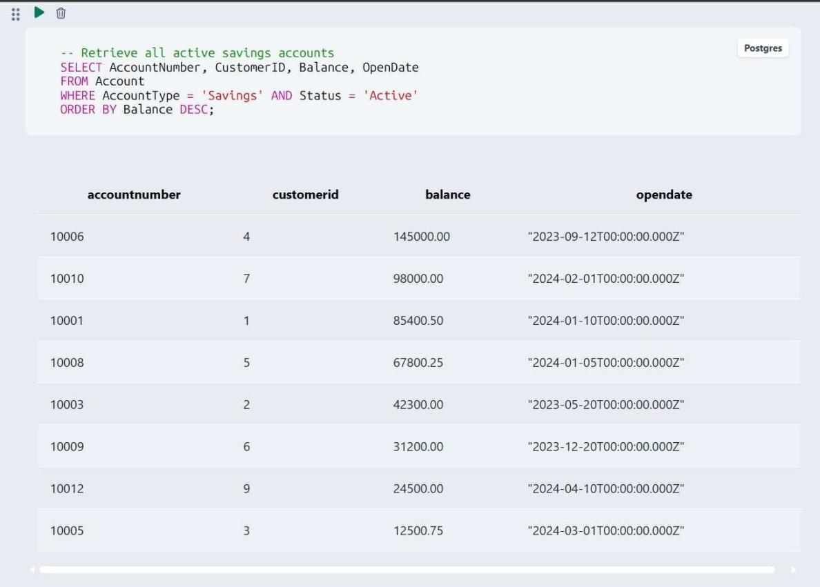
Sample Outputs / Screenshots
Figure 1: Employee records / basic SELECT output

Figure 2: In-progress projects / filtering output

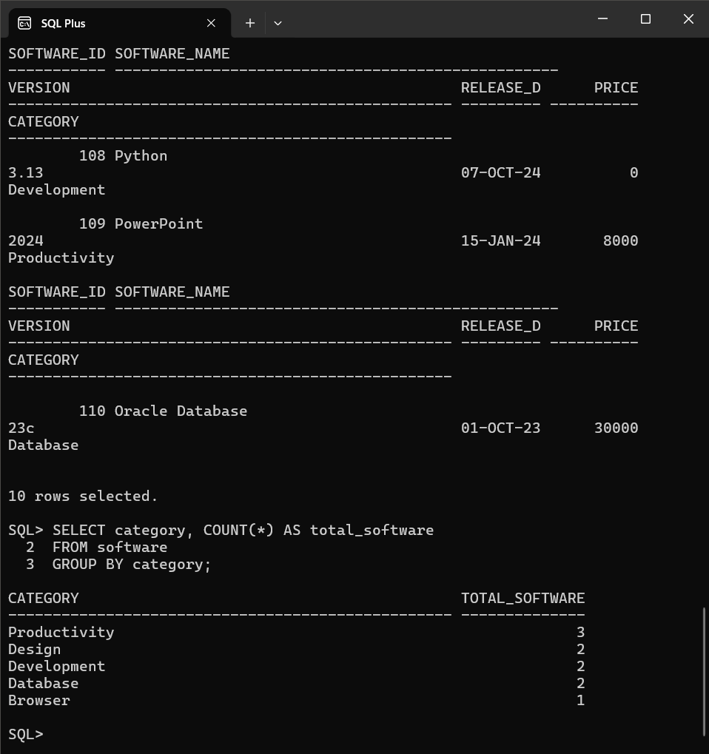

Figure 3: Aggregate or GROUP BY output

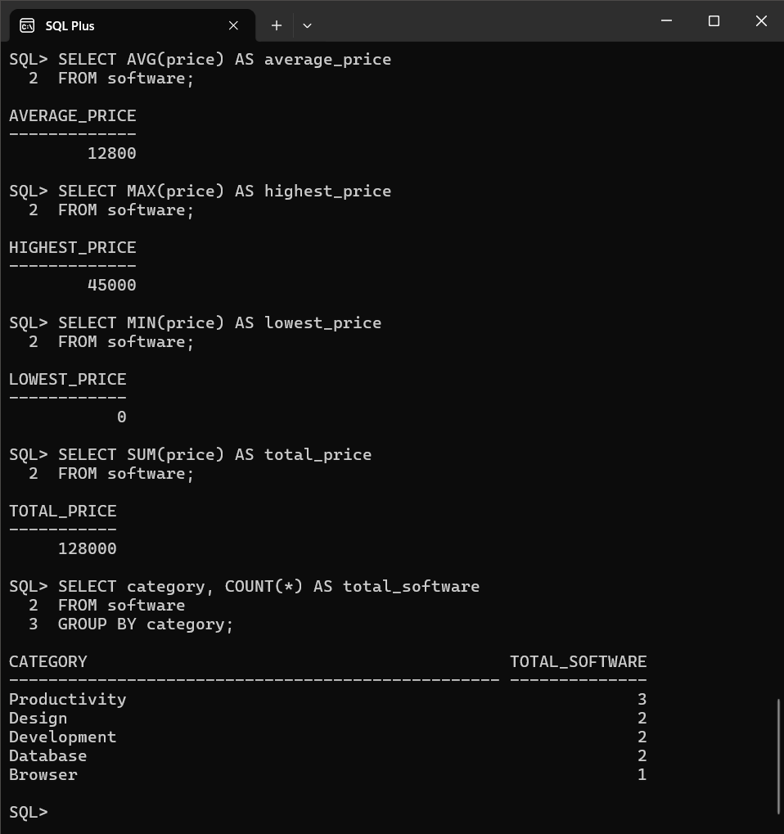

Figure 4: Join or subquery output
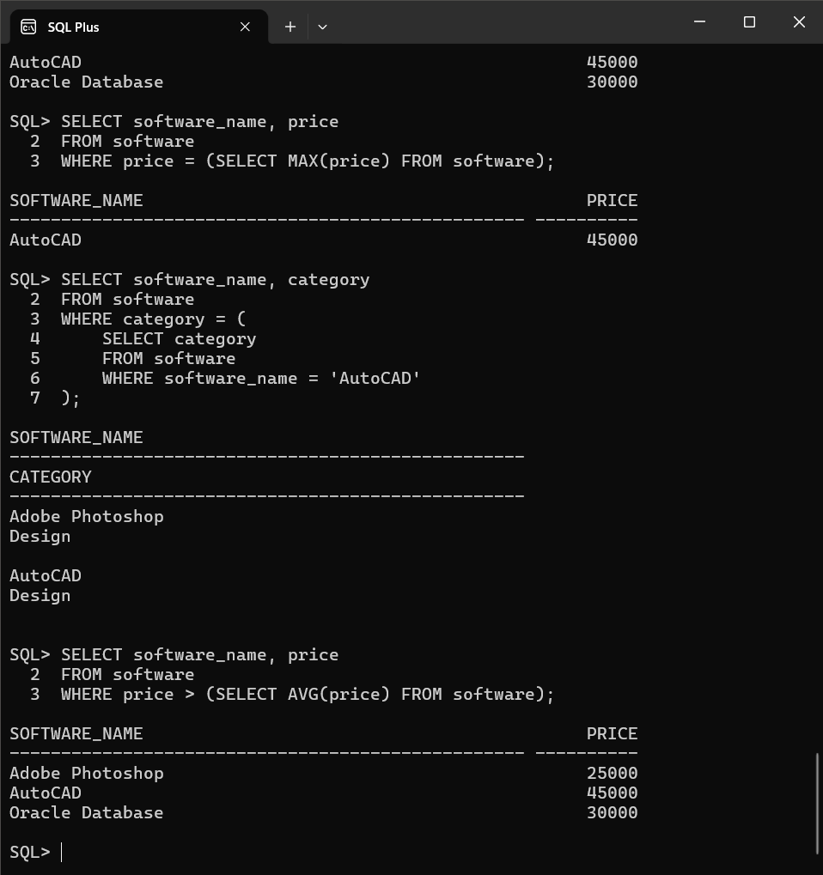

Figure 4: Join or subquery output


MODULES & FUNCTIONALITIES

S.No | Module Name | Functionality
1 | Client Management | Stores and organizes client organization details, contact person, email, phone, city, and creation information.
2 | Employee Management | Maintains employee profiles, roles, departments, contact details, hire dates, and working status.
3 | Project Management | Stores project ownership, manager assignment, budget, schedule, and delivery status.
4 | Module Management | Tracks project modules, lead employees, priorities, due dates, and development status.
5 | Task Management | Records task assignments, estimated/actual hours, due dates, and progress state.
6 | Issue Tracking & Analysis | Stores issue reports and supports defect analysis through aggregate and grouped SQL queries.

GITHUB REPOSITORY & TEAM RESPONSIBILITIES
Repository Link:
Student Name | Roll Number | Role / Responsibility | Contribution Status
B.RESHMA | 26B21AI012 | Wrote DDL scripts for software management tables, keys, and constraints | Completed
A.CHANDINI | 26B21AI002 | Designed ER diagram and relational schema for client-project-task relationships | Completed
T.HARIKA | 25B11AI982 | Wrote CRUD, join, aggregate, and issue-tracking queries | Completed
T.BHARGAVI | 25B11AIC15 | Compiled documentation and prepared screenshot sections | Completed

ENHANCEMENTS & FUTURE IMPROVEMENTS
Future improvements can extend the current database with user authentication and role-based access, richer project dashboards, notification alerts for overdue tasks, sprint and milestone planning, audit logging, stored procedures/triggers where supported, indexing for frequently queried columns, and a front-end interface for project managers and team members. The uploaded SQL files do not include these additional features, so they are proposed enhancements rather than implemented features in the current submission.

CONCLUSION
The Software Management System successfully models the main software project entities and their relationships using a relational database structure. The DDL defines six tables with primary keys, foreign keys, NOT NULL, UNIQUE, CHECK, and DEFAULT constraints. The DML script supplies representative records for clients, employees, projects, modules, tasks, and issues. The query script demonstrates selection and filtering, status updates, task tracking, joins, aggregate functions, GROUP BY/HAVING, and subqueries. The project therefore meets its core objectives of relational design, data integrity, sample-data population, and practical SQL analysis. The team also divided the work across DDL development, ER/schema design, query development, and documentation/screenshot compilation.

REFERENCES
- Uploaded project DDL script: ddl.sql.
- Uploaded project DML/sample-data script: dml.sql.
- Uploaded SQL query script: queries.sql.
- Aditya University - DBMS Capstone Project documentation template.
- GitHub repository: Software Management System (project repository).

APPENDIX

Complete SQL Script
The final SQL implementation is supplied through the uploaded project files:
ddl.sql - database table definitions, keys, foreign keys, and constraints.
dml.sql - sample data for all six tables.
queries.sql - representative SQL operations and analytical queries.
Repository:

B. Additional Screenshots / Outputs
Additional evidence can include SQL execution screenshots showing table creation, sample data, employee/project retrieval, task status updates, aggregate results, joins, GROUP BY/HAVING results, and subquery outputs. No execution screenshots were included in the uploaded source files, so this section is intentionally left for the team to add its actual screenshots.

